David Walters  
CMIS 485  
Project 2

Class: <CMIS485 6380 Web Database Development (2152)

Student Name: David Walters

Instructor: <Dr. Alla Webb>

Assignment #: Project 2

Description: This application allows the create, read, update and delete functions to a basic customer database

for Reston Real Estate company. Default.aspx is the default student webpage for project 2.

Due Date :<2/8/2015>

I pledge that I have completed the programming assignment independently.

I have not copied the code from a student or any source.

I have not given my code to any student.

Sign here: David Walters

**AGENTS**Column Description: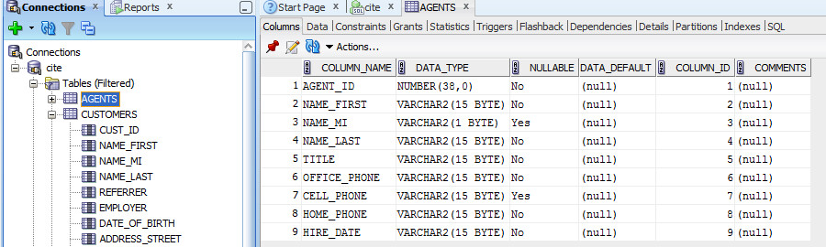

Data:  
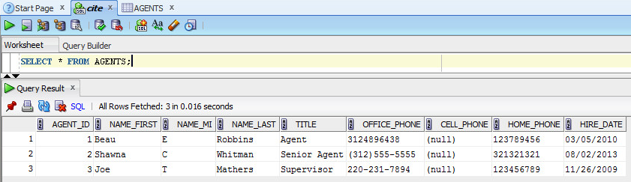

**CUSTOMERS**Column Description:  
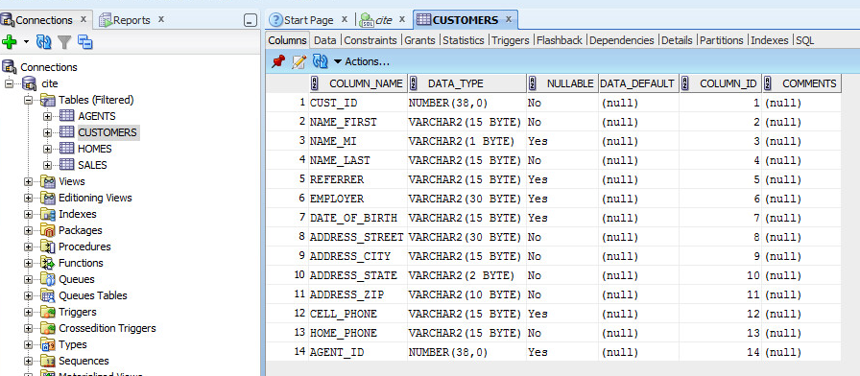

Data:  
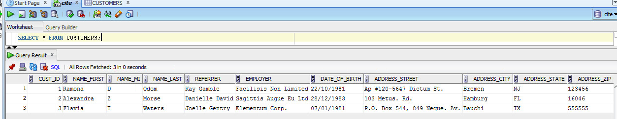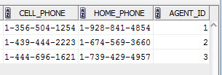

**HOMES**Column Description: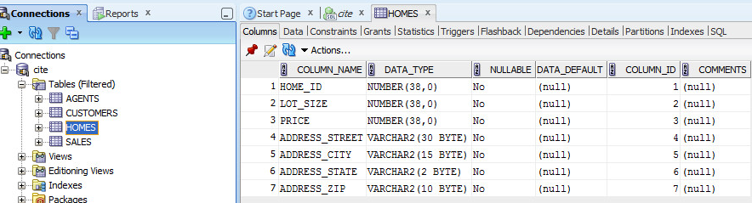

Data:  
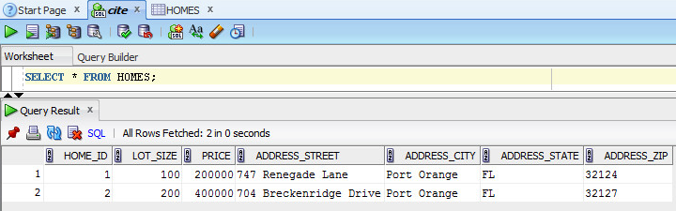

**SALES**Column Description:  
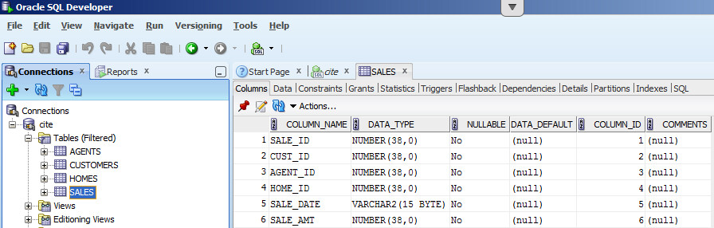

Data:  
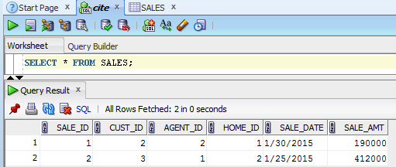

**APPLICATION PROOF OF FUNCTIONALITY AND TESTING**

**Main data display view (Default.aspx):**

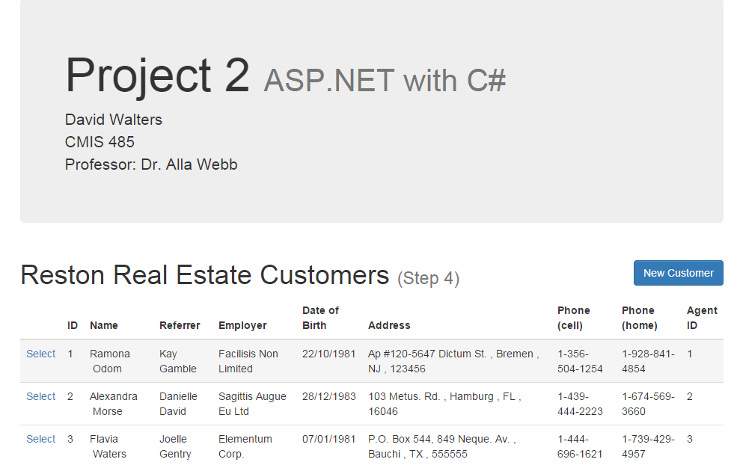

**After clicking on New Customer, Data entry (note bad date for validation testing):**

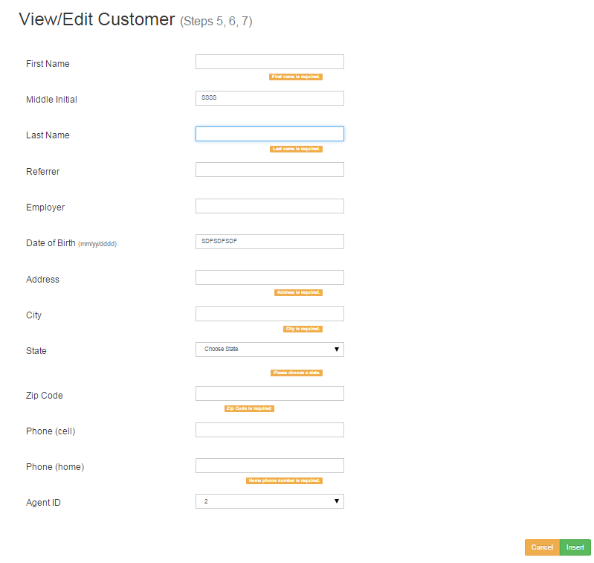

**After correcting data entry to pass validation:**

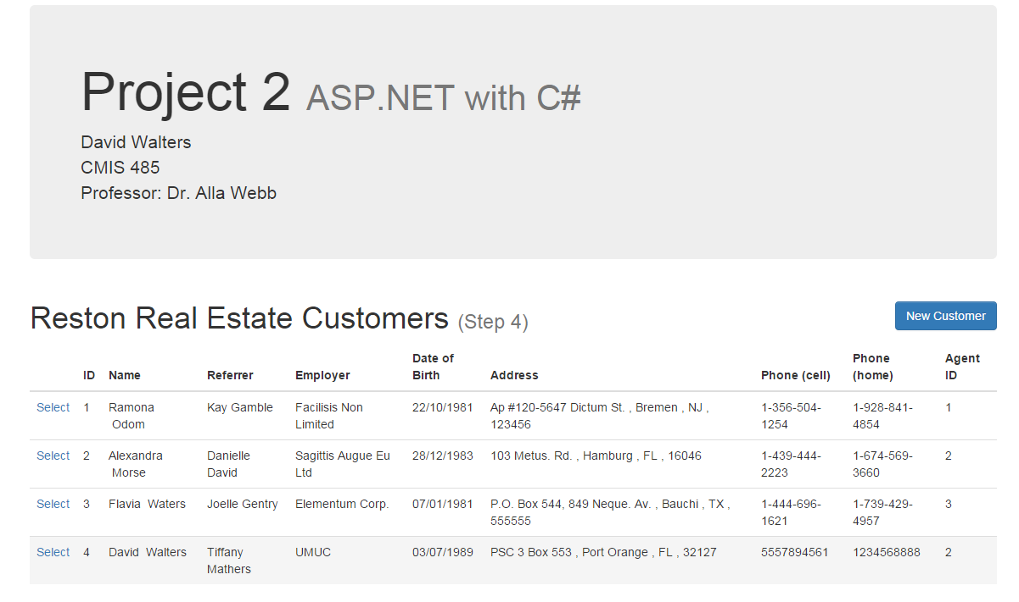

**Selecting a customer to view their record:**

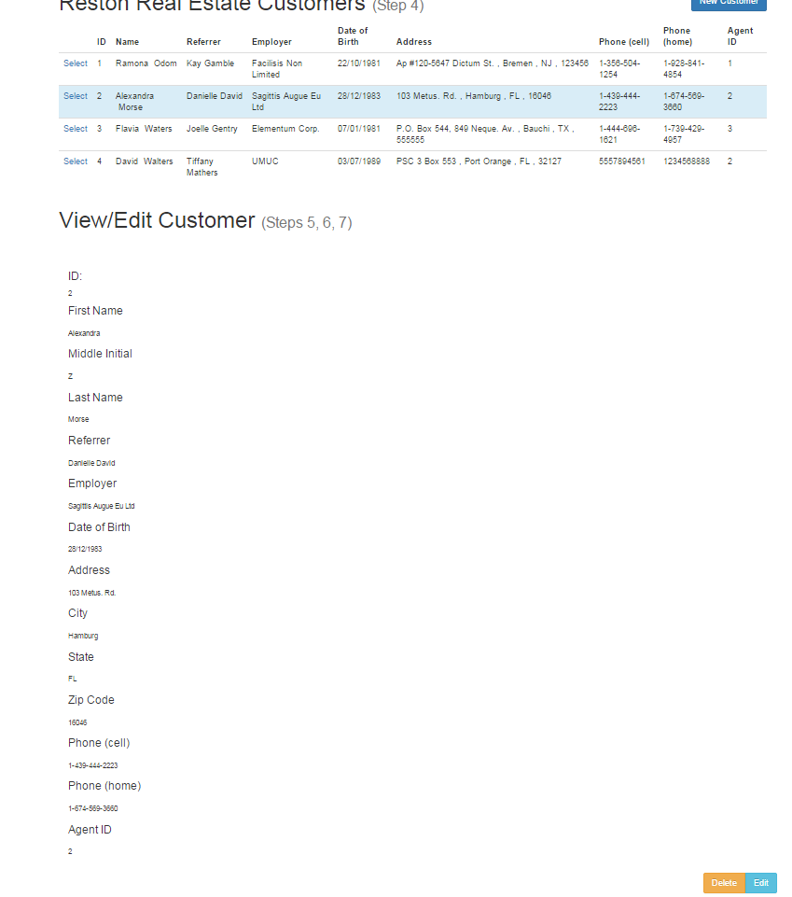

**Editing their record (note bad data to test validation):**

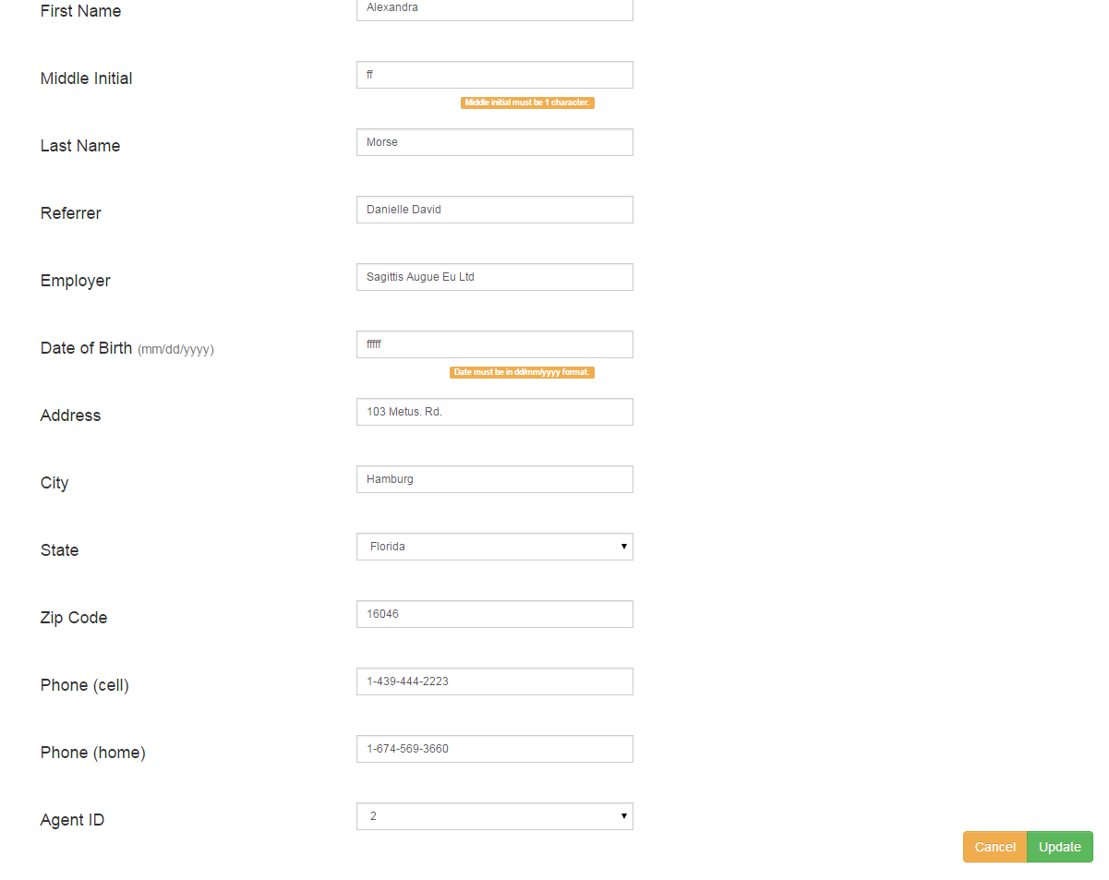

**After entering correct data to pass validation:**

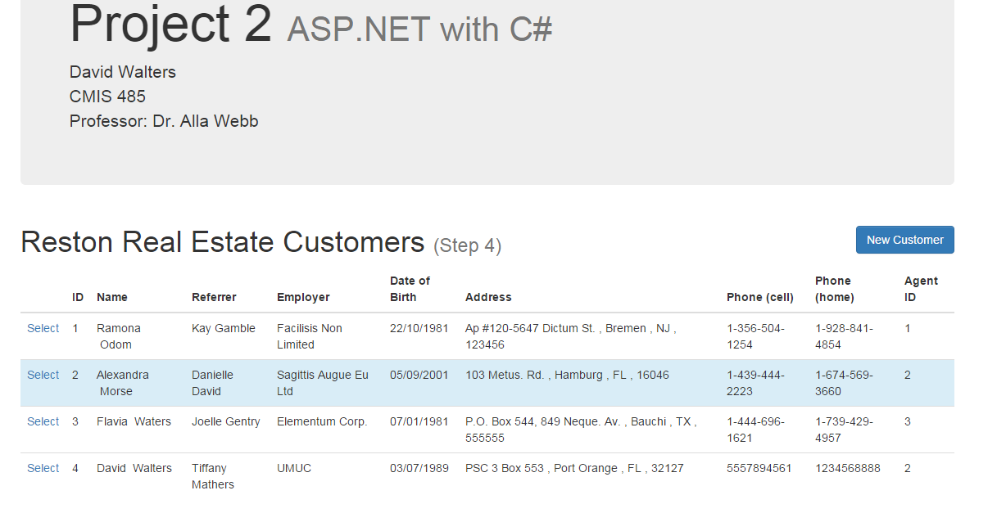

**Deleting a record using the delete button (first select a record, and then press ‘Delete’):**

